

Field Work Report: Kapasa Makasa University Fish Farm
Date: [31/03/2025 ]
Location: Kapasa Makasa University Fish Farm
Participants: Fourth Year Fisheries and Aquaculture Students
SIN:
22171658
22180199
22180200
22175728

INTRODUCTION
A team of fourth-year Fisheries and Aquaculture students conducted fieldwork at the Kapasa Makasa University Fish Farm on Friday. The goal was to complete a number of maintenance duties, such as weeding, slashing the yard, modifying the farm gate with stones, and cleaning up ponds that were empty of fish.

Activities Undertaken

Clearing Ponds Without Fish
- Clearing out the ponds that were now fish-free was the first task. In order to guarantee that these ponds are prepared for future usage, this was essential. Together, the students cleared away any foliage, debris, and other items that would impede the development of aquatic life.

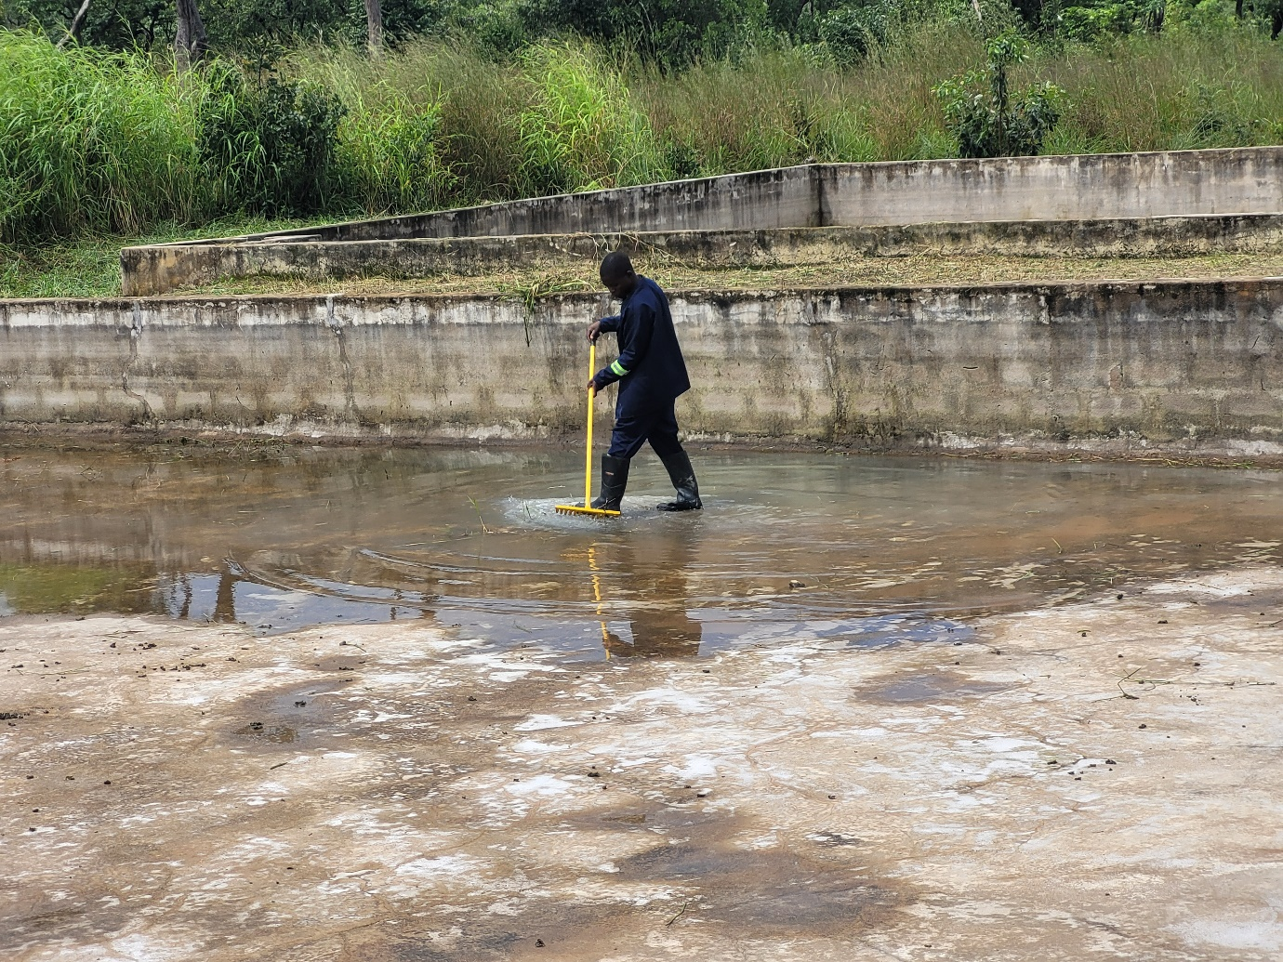
Cutting the Yard
- The group then proceeded to cut the area around the fish farm. In addition to improving the farm's aesthetic appeal, this action reduced the possibility of pests and illnesses that could harm the health of the fish. During this task, the appropriate tools were used to guarantee both efficiency and safety. 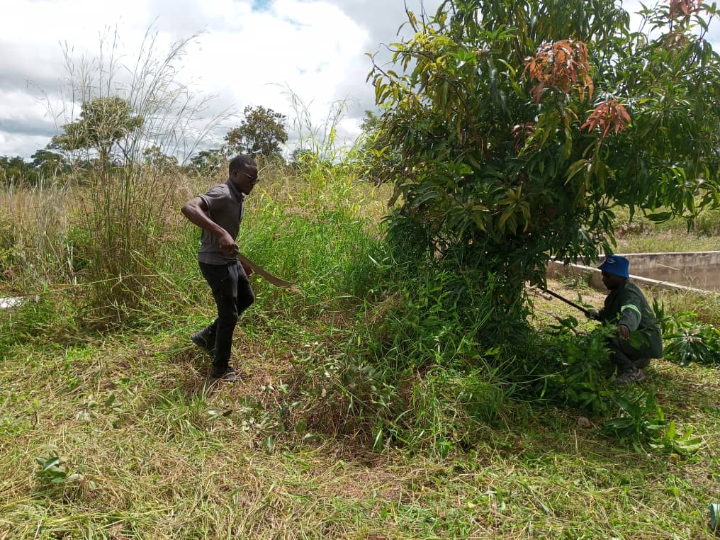

Changes at the Farm Gate
Before
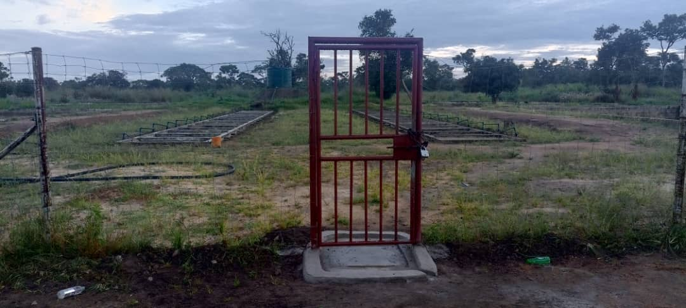

After
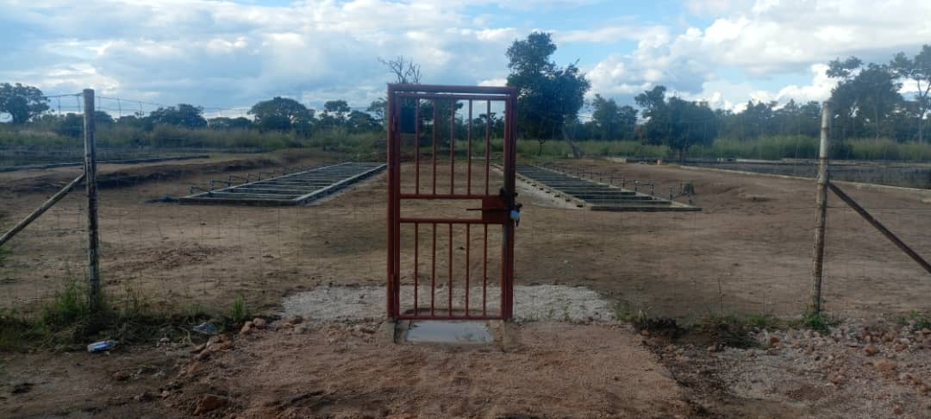

- By altering the farm gate with stones, the students also concentrated on improving the farm's accessibility and security. In order to build a more study construction that will aid in efficiently controlling entry and exit, stones have to be arranged.

Weeding
Another crucial component of our fieldwork was weeding. The group meticulously cleared the area surrounding the fish farm of undesirable vegetation. This promoted a healthy ecology by ensuring that the native aquatic plants were not overpowered and by improving the aesthetic appeal.
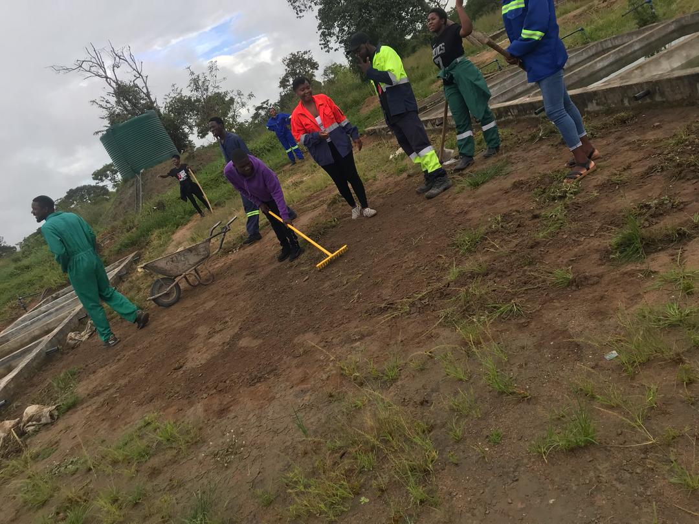

- GROUP MANAGEMENT AND TEAMWORK
The success of our operations throughout the day was largely dependent on efficient group management. Because each member was given specialized assignments according to their areas of strength, operations ran more smoothly. Everyone was able to assist one another and stay on the same page thanks to regular contact.

- Effective Time Management
Effective time management was crucial for this fieldwork. Each task was given a unique time period in the schedule that the team established. This planning made it possible to maximize output and guarantee that all goals were accomplished in the allocated time.
Oversight
- SUPERVISION
Throughout the fieldwork, excellent supervision was visible. The students were guided and supported by knowledgeable faculty members who made sure they followed safety procedures and industry best practices. Additionally, their presence inspired the pupils to give their best effort.

- In conclusion
All participants found the fieldwork at Kapasa Makasa University Fish Farm to be a worthwhile experience. Effective management, teamwork, and the development of practical skills led to the successful completion of every task. In addition to improving our comprehension of aquaculture management, this event encouraged students to work together and take responsibility for their actions.

Fish farm yard photos before and after of the farm
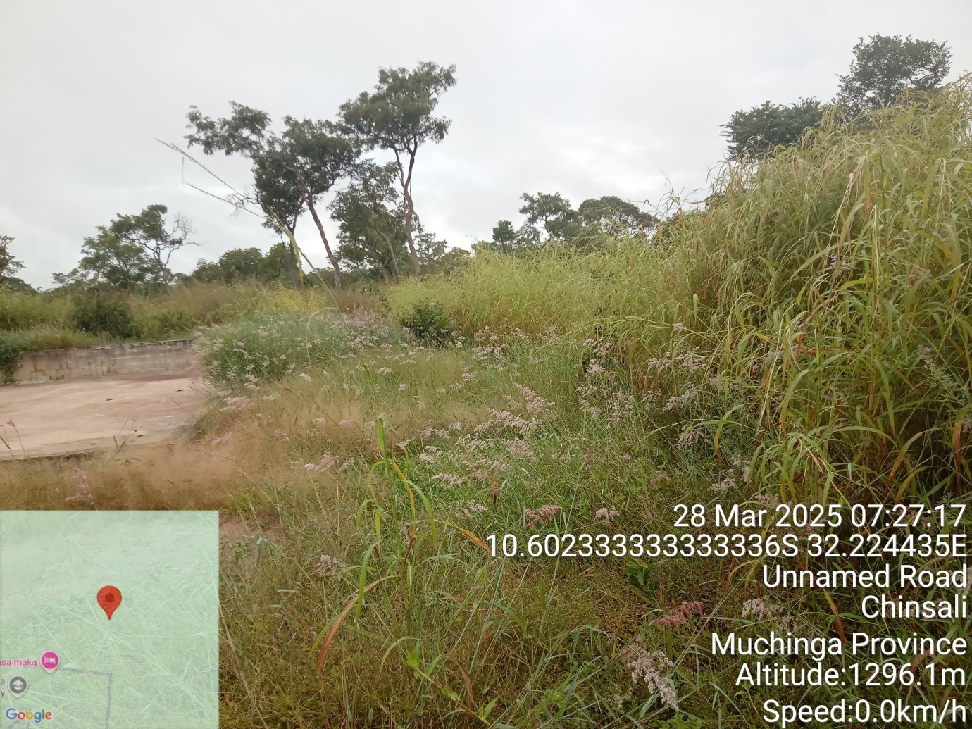
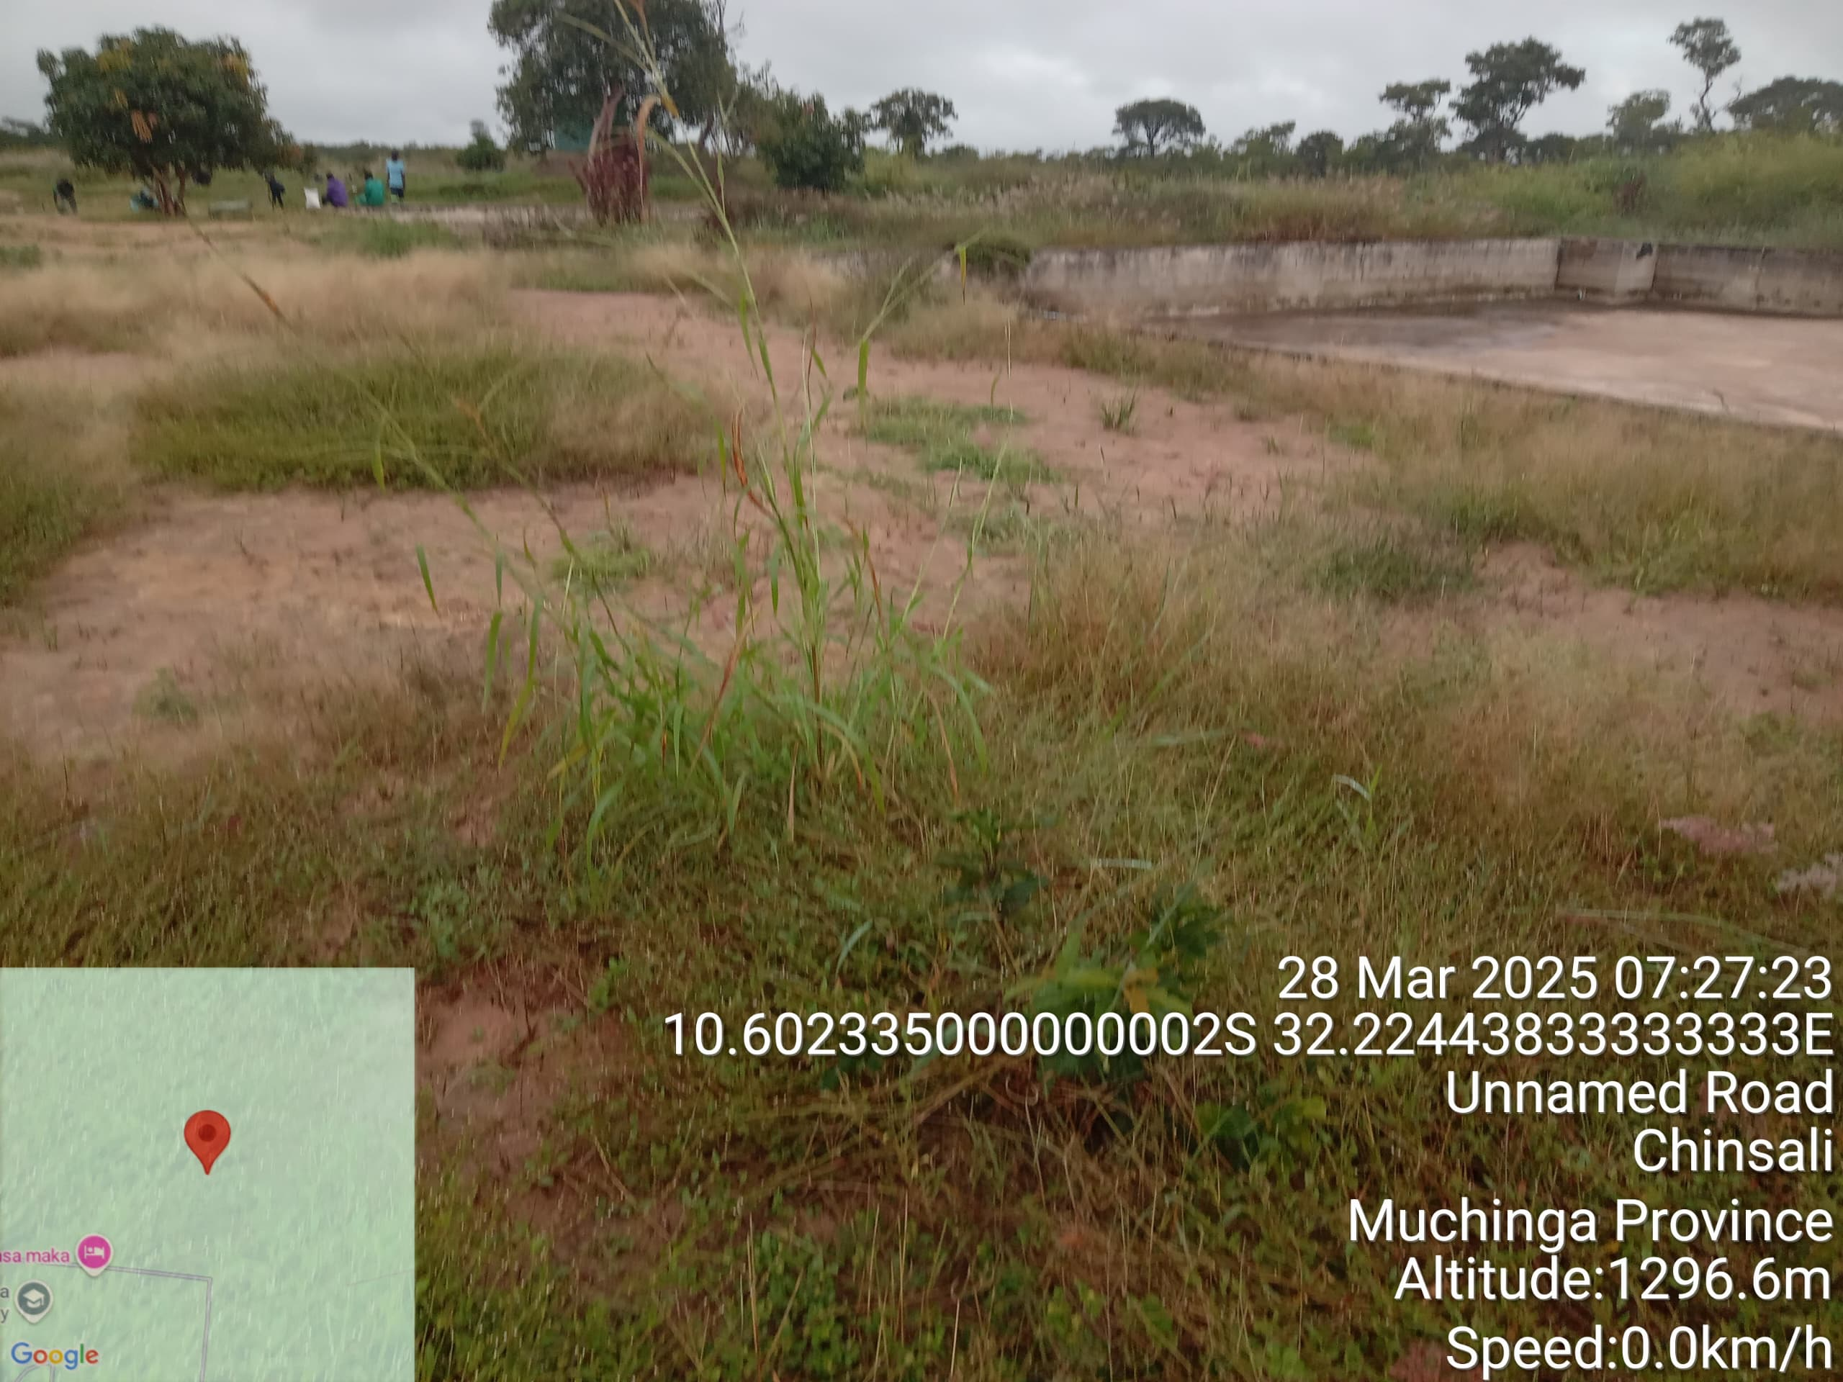

AFTER
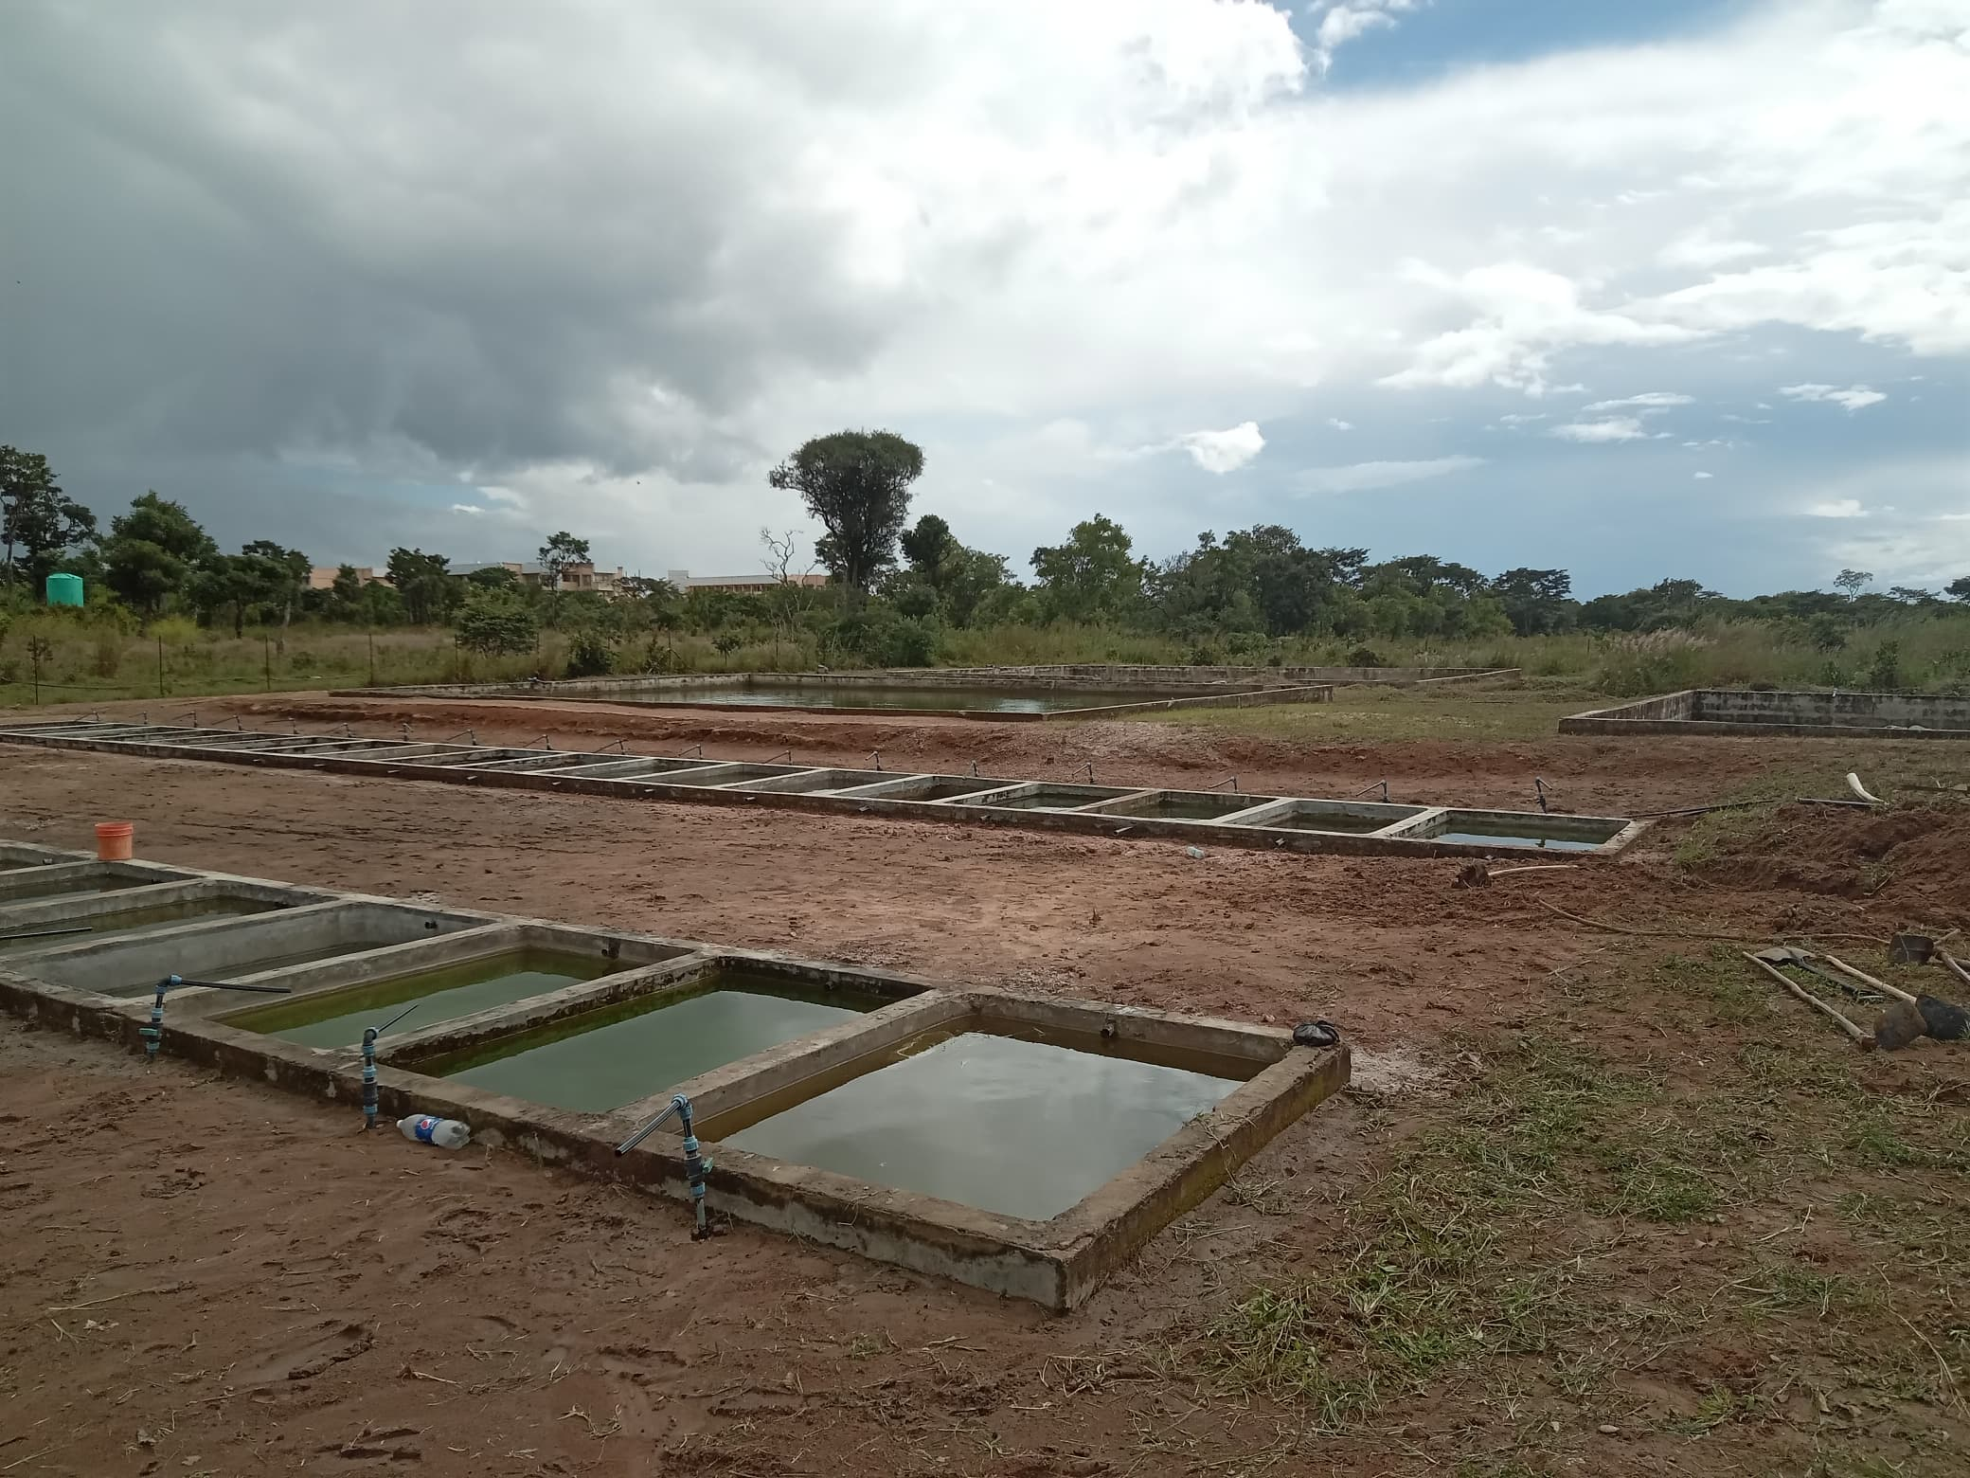
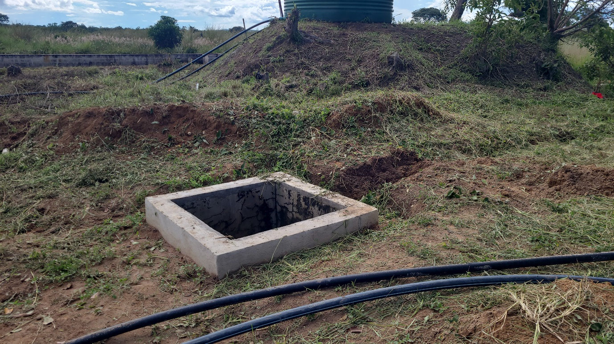
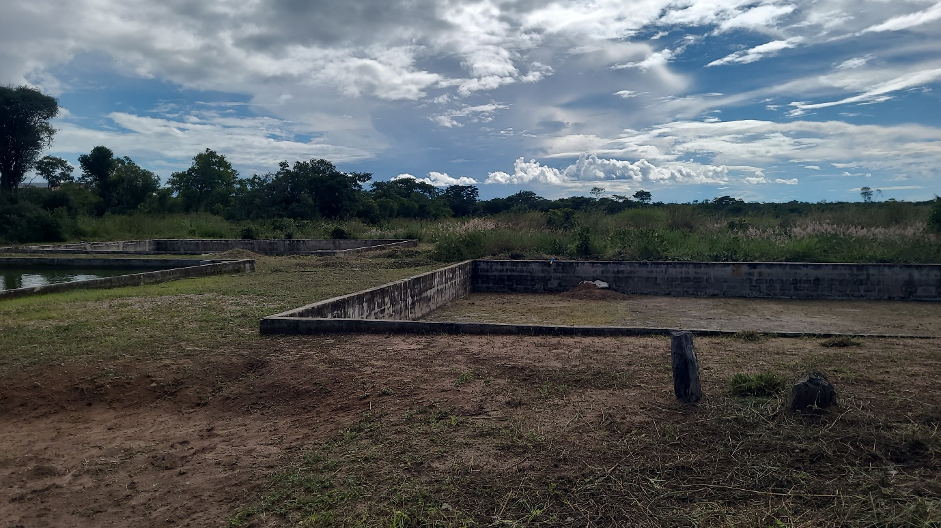
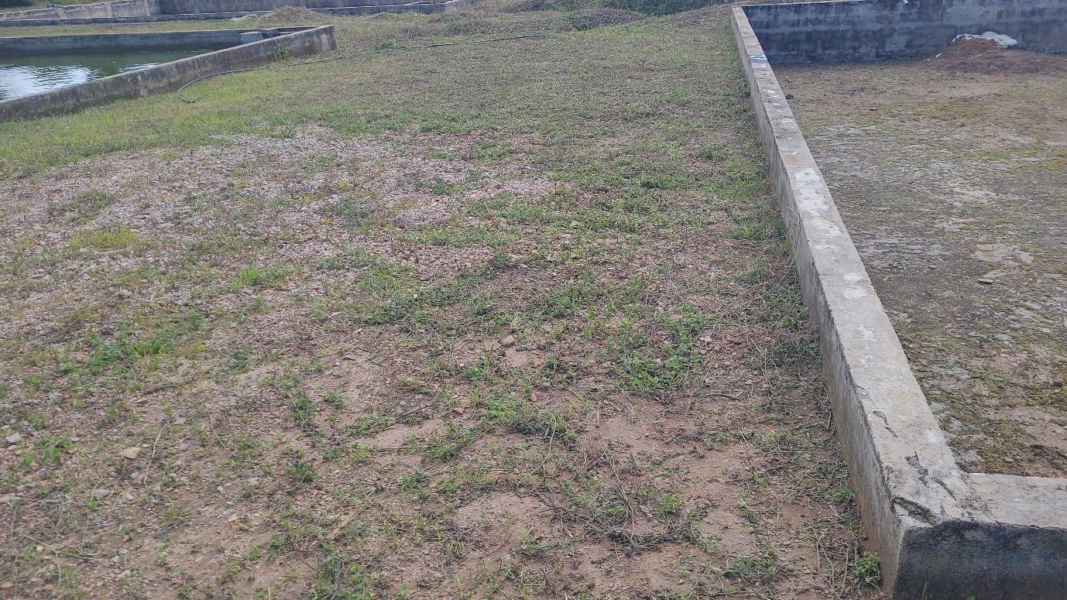

Suggestions
• Arranging extra training sessions on particular duties to improve readiness for upcoming fieldwork; maintaining the fish farm on a regular basis to guarantee optimal operation.
• To improve cooperation abilities, students should be encouraged to cooperate on more cooperative projects.
Hiring workers who are highly trained to make sure they is continuously productions of quality and quantity, and health fish at the market.

Submitted by: [Chisala andrew]
Position: [group Representative]
Date: [I31/03/2025]

